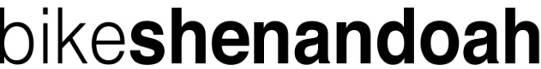
sponsor form
Sponsor's name Address Pledge amt Paid?
Yes No

Rider signature _________________________________________________ Date __________
Rider is responsible for collecting pledges. Suggested minimum: $2 per mile. Make checks payable to Bike Shenandoah.
Receipt will be sent to each sponsor who provides an address.

