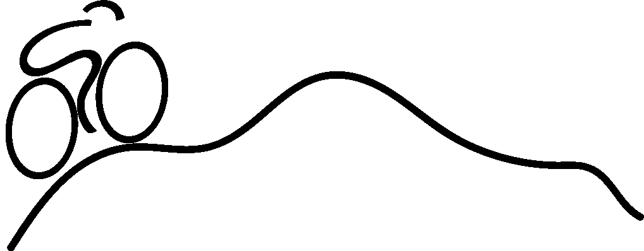
WELCOME! Thank you for choosing to participate in the 25K ride for the 25th annual Bike Shenandoah event this year.
Start time: 10:00 am, Saturday September 17th, 2022
● Please arrive by 9:30 am to check in
● Give yourself 15 minutes or so of easy spinning to warm up
Start Location: EMS parking lot - 801 Parkwood Dr., Harrisonburg, VA, 22802.
Directions:
● Riders will leave as a group promptly at start time.
● Use proper hand signals and obey the rules of the road.
● Use the bike lane when available.
● Ride single file mostly, definitely no more than 2 riders side by side.
● Give plenty of room to the riders next to you to avoid crashes.
● Ride at your own pace - a pace that is comfortable for you.
● Having riding partners choosing to work together at a similar pace will make the ride easier, provide opportunity to get acquainted with fellow riders and help create an enjoyable day while cycling for service.
Ride Markers: Green Dot
● The route is marked with a Green Dot
● The White dot is your reference point.
● Turn right: If the Green dot is to the right of the White dot.
● Turn left: If the Green dot is to the left of the White dot.
● Continue Straight: If the Green dot is above the White dot.
● Other dots: This route mark is also used for other rides so you may see other dots, e.g. the 5K ride follows a Red dot.
● If you find markings are confusing or you see a discrepancy with the cue sheet, the cue sheet provided is the correct route to follow.
● There may be other cycling event routes marked on some of the roads we are using. Be sure to follow the Bike Shenandoah Green Dot markings and not another route.
Notices:
● There may be some heavy traffic along the route. Please watch for vehicles and follow all road rules.
● The route has a few hill climbs. Be sure to stay hydrated!
● The best strategies to avoid suffering from cramped muscles are adequate hydration, eating bananas, avoiding pushing hard in big gears and keeping a pace similar or less than your training pace – staying within your comfort zone.
SAG: (Supplies And Gear)
You will see a SAG support vehicle from time to time. The vehicle will have a sign in the window and is available to provide assistance if you need it.
The signal for having them stop is this: Place your hand on top of your helmet and raise your hand twice. This will avoid confusion for the driver when riders give a friendly wave and so forth.

Minor Waiver Form:
If you are/have a minor, the signed minor waiver form MUST be given at check in to participate in the ride.

After the ride:
Important: Please check in at the registration desk when you finish so we can mark you as safely returned.
Please plan to return to EMS no later than 1pm.

Lunch: provided free for riders (courtesy of our sponsors)
Hours: 11:30 am - 1:30 pm
Location: EMS dining hall
Please wear your mask indoors when not eating and physically distance when possible (families that live together feel free to sit together)

Stay safe and enjoy your ride!

