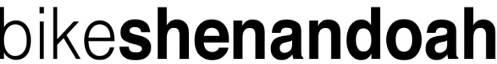
Rider Sponsor Form
Rider Name: ______________________________ Bike Route: _____________

Sponsor’s Name Email or Mailing Address (pls print) Pledge Rec’d? Via?
Example: John Doe JohnDoe@Gmail.com $500 Yes PayPal
1.

2.
3.
4.
5.
6.
7.
8.
9.
10.
11.
12.
13.
14.
15.

Total Number of Sponsors: ___________ Total Dollar Amount: ____________
Rider signature _________________________________________________ Date __________
Rider is responsible for collecting pledges. Suggested minimum: $2 per mile. Make checks payable to Bike Shenandoah.
A receipt will be sent to each sponsor who provides a mailing or email address.

